Flood Management Information System (FMIS)
in Hungary

Lajos Szlávik Civ.Eng., Ph.D.,
Water Resources Research Centre Plc. (VITUKI), H-1095 Budapest, Kvassay Jenő út 1. Hungary, Telephone: +36 1 215 4158, Telefax: +36 1 216 1514, Email: szlavik@vituki.hu

Gábor Jónás Elec.Eng.
UniOffice System's House, H-1111 Budapest, Kende u. 3. Hungary Telephone: + 36 1 372 7575, Telefax: + 36 1 372 7574, Email: jonas_gabor@unioffice.hu

Proceedings of the Fourth International Conference on Hydroinformatics 2000 Conference IOWA, USA (CD)
Flood Management Information System (FMIS) in Hungary

Lajos Szlávik Civ.Eng., Ph.D.,
Water Resources Research Centre Plc. (VITUKI), H-1095 Budapest, Kvassay Jenő út 1. Hungary, Telephone: +36 1 215 4158, Telefax: +36 1 216 1514, Email: szlavik@vituki.hu

Gábor Jónás Elec.Eng.
UniOffice System's House, H-1111 Budapest, Kende u. 3. Hungary Telephone: + 36 1 372 7575, Telefax: + 36 1 372 7574, Email: jonas_gabor@unioffice.hu

ABSTRACT: In Hungary, owing to the particular geographical conditions, important and steadily growing public interest has been attached to flood control for centuries. Of the 93 000 km² large territory of the country 23% are exposed to inundation by recurring river floods. As a result of flood control developments since the middle of the 19th century these flood plains are presently protected by over 4000 kms of earth embankment, which rise 3 to 8 m above the surrounding terrain. FMIS created by integrating into a network the roughly 400 workstations at the centres of the 17 institutions involved in handling flood emergency operations on national and local levels, has been operating on a routine basis since July 1, 1994. The FMIS ensures the integrated co-operation of complex, highly automated application based on the Lotus Notes Groupware.

INTRODUCTION

Hungary ranks high on the world list of countries exposed to flooding, close to 23 and 10% of her territory being flood plains along major streams and minor rivers, respectively.
Flood control in Hungary has been successful in recent years: the flood levees flanking the rivers have withstood safely the floods for almost two decades, the last flood causing loss of human life has occurred in 1956. This is attributable to carefully planned development and organizational efforts.

FLOOD EXPOSURE IN HUNGARY

Owing to the particular geographical conditions, important and steadily growing interest has been attached in Hungary for centuries to controlling the losses by river floods. The fundamental cause of the high flood hazard is the situation of the overwhelmingly plain country in the deepest part of the Carpathian Basin (Fig. 1), so that the flood waves which arrive from the surrounding Carpathian and Alpine mountain catchments tend to overtake each other and create often emergency situations.
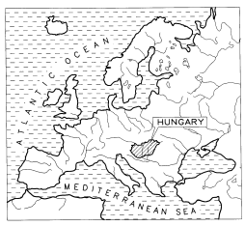
Fig.1. The situation of Hungary within Europe

The streams in Hungary belong to the catchments basins of two large streams, the rivers Danube and Tisza. Disregarding a few minor streams, all rivers in Hungary originate beyond the national boundary and discharge to
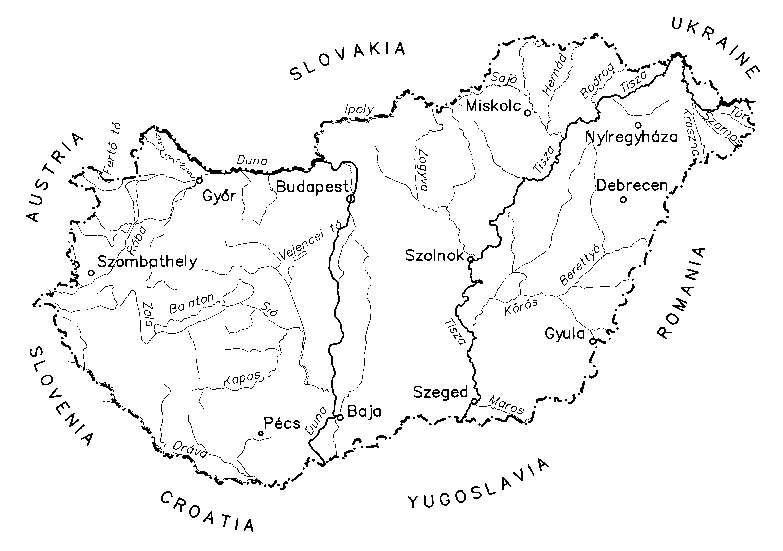
Fig.2. . The major streams of Hungary

the recipient Danube and Tisza (Fig. 2). With a total length of 2822 km the two major streams drain virtually the entire territory (93 000 km²) of Hungary. The rivers arriving at the Hungarian border convey the runoff from 290 000 km², that is an area three times as large as the territory of Hungary. The flow regime in these rivers is controlled therefore overwhelmingly by the hydrometeorological events over the headwater sections.
Of the 93 000 km² large territory of the country 21 248 km² (22.8%) are floodplains, levees protecting 97% thereof against inundation by river floods.
Fig.3. Comparison of the major flood control
developments in Europe
Facts and figures on the reclaimed flood plains: 2.5 million people in close to 700 communities are exposed to flood hazard; one-third of the arable lands in Hungary, 18 000 km² valuable farmland; the flood plains contain 32% of the railway lines and 15% of the roads; over 2000 industries have settled here, and about 25% of the gross domestic product is produced here.
The level of flood exposure in terms of the ratio of flood plains is the highest in Hungary of all European countries and is comparable with the situation in the Netherlands alone (Fig. 3).
The Tisza and her tributaries responded to the cutting of meanders and reducing the width of the flood plains by considerably higher flood levels, the fast sizing process continuing to these days on the Hungarian rivers (Fig. 4).
Fig.4. Rising flood peaks on the Tisza and her tributares

FLOOD DEFENSES IN HUNGARY

The existing flood defenses built since the middle of the 19th century comprise the main-line levees of 4003 km total length (3973 km earth embankment, 30 km flood wall) along the rivers. The total volume of the embankments is approximately 120 million m³ (Fig. 5).
The standard against which the defenses are assessed is the design flood, which these are required to withstand.
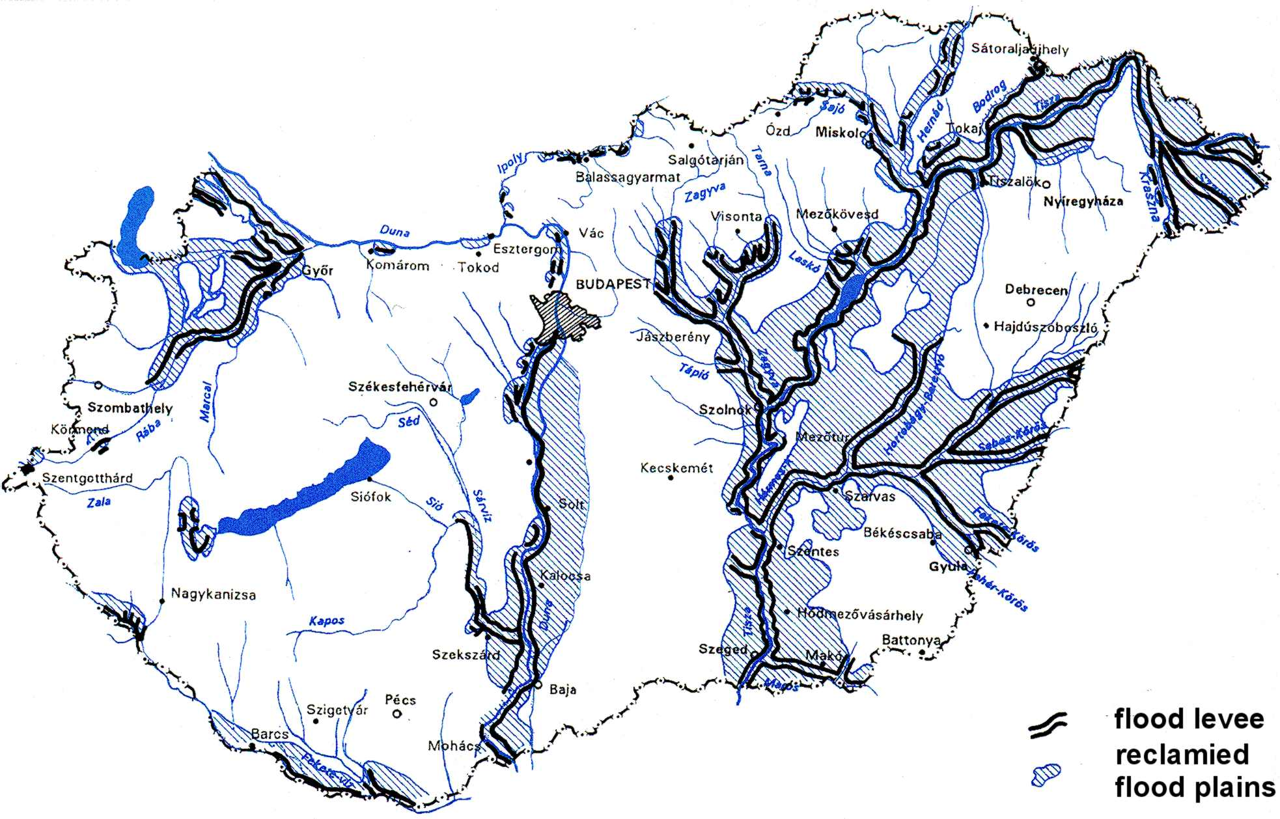
Fig.5. Flood defenses and protected flood in Hungary

Under the provisions currently in force in Hungary, the defenses must be dimensioned to withstand safely the ”one in hundred years” (”one in thousand” along major towns) ice-free flood, at a safety freeboard of 1.0-1.5 m. Considerations of safety, traffic and transportation on the crest in emergency situations, further of maintenance with mechanical conditions are involved in deciding on the minimal cross sectional dimensions. The resulting embankments rise locally more than 5-8 m above the surrounding terrain.

INSTITUTIONAL BACKGROUND, THE EMERGENCY ORGANISATION

Control in flood emergency situations is assigned by law to the state. Within the central government it is the Minister of Transport, Communication and Water Affairs, who is responsible for the water management functions, thus also flood management, and who is vested – in grave emergencies – with the powers of a government commissioner. He is assisted in performing these functions by the staff of the water department supervised within the ministry by an undersecretary of state. The national professional agency subordinated to the minister to perform the operative functions of water management is the National Water Authority (NWA). In handling emergency situations the 12 Regional Water Authorities (RWA) organized by catchments play a role of decisive importance. The Central Water Emergency Organization is presently responsible for performing the special tasks of emergence control all over the country, like operating the emergency squad, the icebreaker fleet, blasting ice jams, etc. Collection and dissemination of hydrologic data, the compilation of flood forecasts are performed by the National Hydrological Forecasting Service, a unit of VITUKI Plc.
The 12 RWAs organized by catchments are state agencies financed from the central budget to perform the water management functions of the state. They function in a practically unchanged form since 1953 and are substantially the legal successors of the land drainage and river engineering districts established in the last third of the 19th century. With a total staff of approximately 5000, they operate also the hydrologic observation network (some 5600 gagging stations).
Flood fighting is listed among the priority functions of the RWAs. The procedure is controlled by acts of legislation, in which the persons responsible for specific activities are also identified. Implementation of emergency control includes engineering and administration measures.
- The engineering measures include operations on the levees, hydrologic forecasting, confinement of inundating water.
- The administration measures are: mobilization of the public workforce for flood fighting on the levees, taking care of the population in the event of a levee failure (rescue, evacuation, accommodation), saving property, health care, restoration.
The water agency is required to provide guidance for the engineering measures of emergency control, for which the manpower and technical equipment are secured by the municipalities, the civil defense and the army.
According to the provisions of Act LVII of 1995 on Water Management, national control of flood emergency operations belongs to the sphere of authority of the minister up to the announcement of highest alert level. The minister discharges his duties via the NWA. For the highest alert period the minister is vested with the powers of a government commissioner in guiding emergency operations. In especially grave hazard (disaster) situations a state of emergency is declared at set forth in the Constitution and national guidance of operations is transferred to a government committee.
In major flood fighting operations (for instance the recent 1998 November and 1999 spring floods) 5000 employees of the water service and 10-15 thousand other emergency workforce were mobilized.

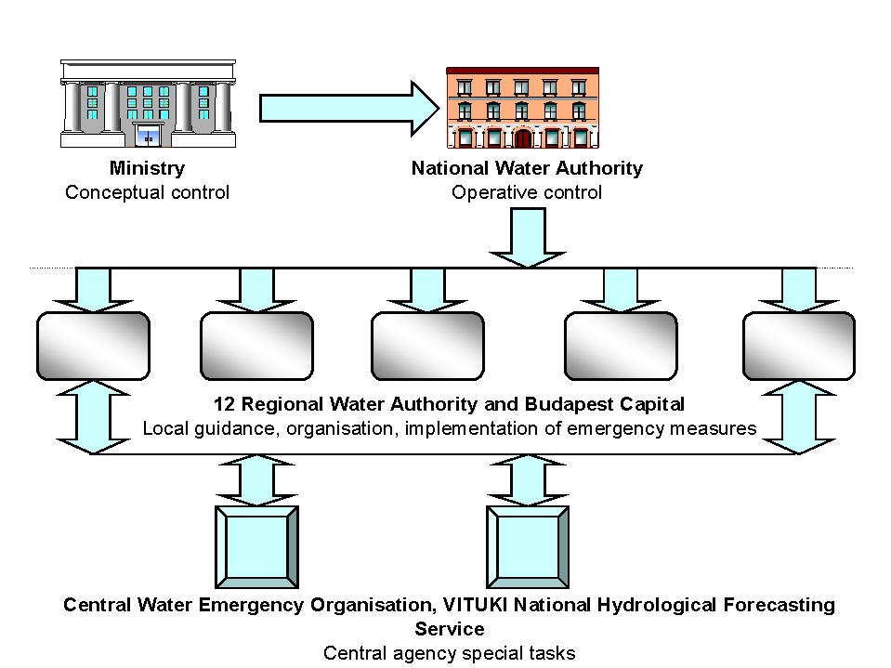
Fig.6. Functions and hierarchic relations in flood emergency control

Major flood emergencies are impossible to control, unless a number of agencies cooperate in a concerted manner. Their functions and hierarchical relations are set forth in laws and other acts of legislation. The main agencies involved in implementing emergency measures on the state-owned inundation control structures and their functions are as follows (Fig. 6):
Fig.7. Links of a regional water authority during flood emergency
- the twelve district water authorities and the capital Budapest – local organization, guidance and actual implementation of flood emergency measures;
- the Ministry of Transport, Communication and Water Management, the National Water Authority – national level organization and control;
- the Central Flood Fighting Organization and the WaterResources Research Centre (VITUKI), National Hydrological Forecasting Service – national level special functions.
A wealth of information covering a broad range of subjects is exchanged between the cooperating agencies (17 at the present). This has been reviewed, screened for potential overlaps, and rationalized where necessary when the various modules of the flood management information system were planned. Establishment of the communication links capable of handling this flow of information is one of the important goals of the envisaged system, parts of which are being built, parts operating already.
All co-operating agencies have extensive horizontal communication relations, forwarding information to, and receiving information from, the co-operating partners (Fig. 7). Data transfer between these partners involved in the horizontal relations of the emergency control organizations is effected over conventional channels. Data reporting and information forwarding to them is handled in the system as outputs, the technical solution of which depends on the means and technology available at the receiving partner.
According to the level of control, the co-operating agencies are grouped into local (regional) and national categories. This classification means at the same time that whereas actual emergency operations are also performed at the local level, the incoming information is summarized and evaluated at the national level. The local level can be subdivided further into levee sections and local emergency center. The latter comprises the emergency officer, the emergency staff and the special groups (hydrologic forecasting, soil mechanics, supplies, etc.) at their service (Fig. 8).
The resources, methods and types of information needed for carrying out the emergency operations can be listed under the following headings:
- manpower and materials;
- communication equipment;
- calculation equipment and aids;
- local data base, files;
- imported information;
- engineering computation methods, models algorithms;
- instructions, regulations (decision tables).
Fig.8. Flood emergency control levels

INFORMATICS BEHIND THE DECISION SUPPORT SYSTEM OF FLOOD PROTECTION

The FMIS objectives and functions

Regardless of level of control, one of the major problems stems from the difficulty of reviewing and assessing all the potentially available information during the time span available for decision making on a particular control measure. The task of logistic support to emergency control is therefore to integrate (assemble and pre-assess) information with the basic aim of improving the effectiveness of flood fighting operations by modernizing data handling and transfer. This comprises in particular:
- extending the lead time for preparing emergency measures;
- providing information processed, analyzed, assembled, compared and presented at the highest possible level for decision making on alternative emergency measures in a particular emergency situation. Continuous updating of information, which is especially important in emergencies of larger scope. In short, securing faster the amount of information needed for supporting emergency control decisions, processing it as far as possible, storing it in an identifiable manner and indicating the potential implications.
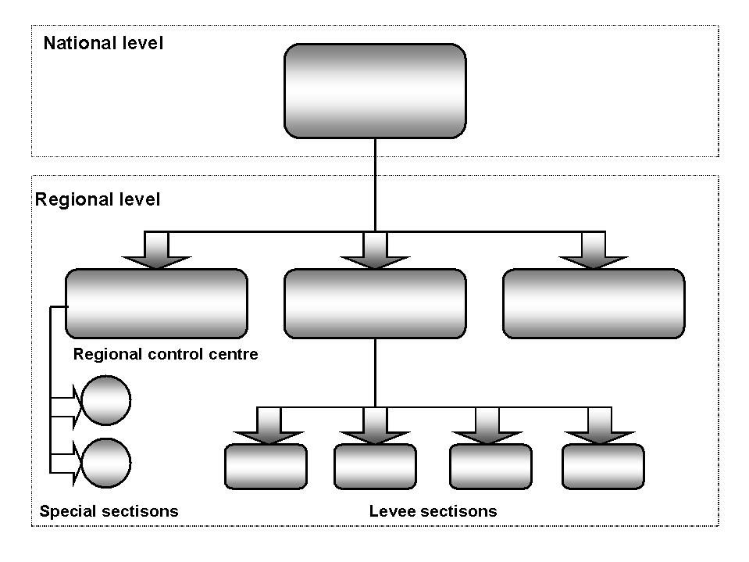
Considerable importance was attached to introducing the various FMIS elements simultaneously at each of the co-operating agencies in order to maintain the same level of capacity throughout the system.
FMIS functions:
- supporting the emergency control activities at the particular agency on a local area network,
- ensuring information flow to and from emergency control levels above and below the particular agency via the channels of communication.
FMIS serves thus two objectives and is capable of performing two compatible functions simultaneously: supporting the local emergency control activities and acting as a communication interface to the connected levels of control. The first function is one related primarily to computer technology, the second to data communication.
The professional tasks, methods and procedures of guiding flood fighting are set forth in acts of legislation, manuals and instructions. The following tasks are obligatory at all levels of control:
- collection, recording, processing and forwarding information;
- situation analysis, assessment, decision preparation;
- decision making on flood fighting measures;
- organization, guidance of flood fighting activities, supervision of their implementation;
- preparation and forwarding reports and information;
- documenting these activities.

Flood fighting depends for its effectiveness on a wealth of information. The techniques of information gathering and processing, the methods of situation assessment must be uniform throughout the service. The reports must be standardized in both substance and format, information flow between the various interrelated levels of control must be coordinated, overlapping data communication (on the hydrological situation, stages of alert, resources used and required, etc.) must be eliminated.
One of the major problems at all levels of control stems from the difficulty of reviewing, assessing during the time available for preparing decision on a particular measure all the information which is potentially available. The fundamental possibility and task of providing logistic support to emergency control was therefore the integration of information. The basic objective was formulated to improve the effectiveness of flood fighting operations. In the interest thereof efforts were made at extending the lead time of preparing emergency operations, further at providing more, better processed, analyzed, clearly presented information for decision making on alternative emergency measures in particular emergency situations.
The FMIS functions comprise thus the provision of support to emergency control activities emerging at a given organization on the local computer network, on the other hand of ensuring information flow for control levels above and below the particular emergency control level via the channels of communication.
The two elements of decisive importance in the FMIS are the operating software and the technical solution of data communication.
- The FMIS ensures the integrated co-operation of complex, highly automated application based on the Lotus Notes Groupware.

ORGANIZATIONAL STRUCTURE AND OPERATION OF FMIS

The FMIS structure

The FMIS sub-systems comprise:
- Information on the hydrological situation
- Surveillance reports on the defenses
- Emergency diaries, emergency administration
- Reports, information
- Management of emergency resources
- Flood fighting aids
Depending on the levels of emergency control at which information is processed and between which information is exchanged, five FMIS application levels are distinguished:
- Information processing at the defense section centers
- Information exchange between the defense section centers and the local (regional) control center
- Information processing at the regional center
- Information exchange between the regional and the national control levels
- Information processing at the national control center
The flood management information system functions continuously, in that the basic modules operate without interruption, switching on additional modules depending on the hydrological situation liable to call for emergency operations.
The central FMIS module is a program, which keeps record on the completed parts of the system, on the contents and interrelations thereof, operates continuously the module keeping track and assessing the hydrometeorologic and hydrologic situation, and issues alerts as required.
Based on the Lotus Notes software a complete closed-system communication network has been set up to cover all water agencies of the state. This is of paramount and decisive importance for further information developments. FMIS is not confined to supporting emergency control activities alone, in that the possibility of processing further the electronic documents creates a the data base of flood emergency measures accumulating a wealth of practical experience.

Functionality of the system

Our implementation of FMIS is a complex and integrated automated application suite based on Lotus Domino/Notes technology. It has been developed by UniOffice System House in close co-operation with the national flood management authorities. Version 1.0 was implemented in 1994. 1999 saw the transition to version 3.0 of most system components.

Functional components
The system consists of four main functional components:

- Subsystem of logging and preventive measures (defense levels module, organizational setup module and people module)
- Subsystem of reports (briefing modules, maintenance module, daily defense reports module)
- Subsystem for providing hydrological information (module for hydrological communication, integrational module for the hydrological information system integrative module)
- Subsystem of additional components (professional Help databases – e.g. professional and legal manuals, IT application manuals – e.g. Lotus Notes, flood management information dictionaries, summative overview module, special Hungarian mailing module).

Communication functionality
The primary functionality of the system is communications. This means ”traditional” transfer of messages as well as automated and scheduled forwarding of flood management data. Such messaging and replication technology (a feature of Lotus Domino servers and Notes clients) is part of the appropriate FMIS module databases. A latest addition to the communication functionality is the transfer of data records stored in an SQL server table at one location to another server table stored at another location through Notes mailing technology.

Date sharing functionality

Accessibility to public data is not limited to internal (Lotus Notes) users. Data are also published on the web on-line, providing appropriate internal and external availability (intranet and Internet functionality). Data stored in certain back-end Lotus Domino databases is made accessible to relational database management systems through Lotus Enterprise Integrator on an automated and scheduled basis. Data produced by reporting modules are accessible to office applications through the standard ODBC interface.

System architecture

List of components:
- 51 Lotus Domino application servers (which optionally function web servers and SMTP MTAs as well)
- 15 Microsoft SQL servers
- more than 400 Lotus Notes workstations in 17 regional centers and at about 100 locations across the country
- telephone communication lines (33600 bps), leased analog lines and ISDN connections
- Lotus Domino Fax Gateway at regional centers for outbound faxing
- Lotus Enterprise Integrator based data connection between Notes and relational databases
- 45 unique FMIS-oriented Lotus Notes application-modules
- 4 additional Lotus Notes modules (sequential number generator, attach, detach, trashcan)
- cc:Mail connectivity

Networking models

Local networks of the regional water authorities are the basic components of the system. Each of these is represented by one Lotus Domino domain. These local networks boost Lotus Domino application modules that are accessible to the users via the Lotus Notes client or a web browser. Reliable operations are provided by a continuously running backup server at each location, ready to take over the role of the defective main server in a few minutes in case of server failure.
The national network is comprised of the local Domino servers and a central one running at the headquarters of the National Water Authority. Communication and data flow processes are carefully designed and optimized. Regional locations without Domino connectivity are informed by faxes sent out automatically by the reporting application modules through the Domino Fax Gateway

Databases, applications

Databases in the system can be categorized into three main types:
- Personal mailboxes (standard Lotus Notes mailboxes with additional process-oriented functionality)
- Back-end databases (storing professional back-end data – e.g. reference values – and data needed for system maintenance)
- Operational application modules (Lotus Notes databases with mail-in capabilities to provide ”instant” forwarding of reporting messages and data to the target location.)

Data transfer solutions, system processes

Scheduled data transfer (replication)
Data stored in Lotus Notes modules and SQL tables are synchronized across locations on a daily basis using a radial topology of Lotus Domino replication.

Instant data transfer (electronic mail and mail-in databases)
Standard electronic mail is a service of the underlying Domino/Notes infrastructure. Besides personal mail, critical data are transferred to all locations with this technology as the application databases are ready to send and receive such messages (mail-in database technology).

Automatic file transfer
The national Lotus Domino communication network is also a vehicle for file transfer between locations. A unique pair of server modules (attach and detach) take care of transferring files between the file systems of servers running Domino. Parameters of the process include locations of the files and the scheduling of the transfer. Using this technology, any kind of data can be transferred between the file systems of the local servers.

7. THE FMIS IN USE

The first applications were started in the first half of 1994 between the centers of 17 institutions directly involved in flood emergency control. Regular, routine FMIS applications have been continuous since July 1, 1994. Over the past five years several hundred thousand electronic mail was exchanged between the co-operating partners with a high level of availability and reliability.

