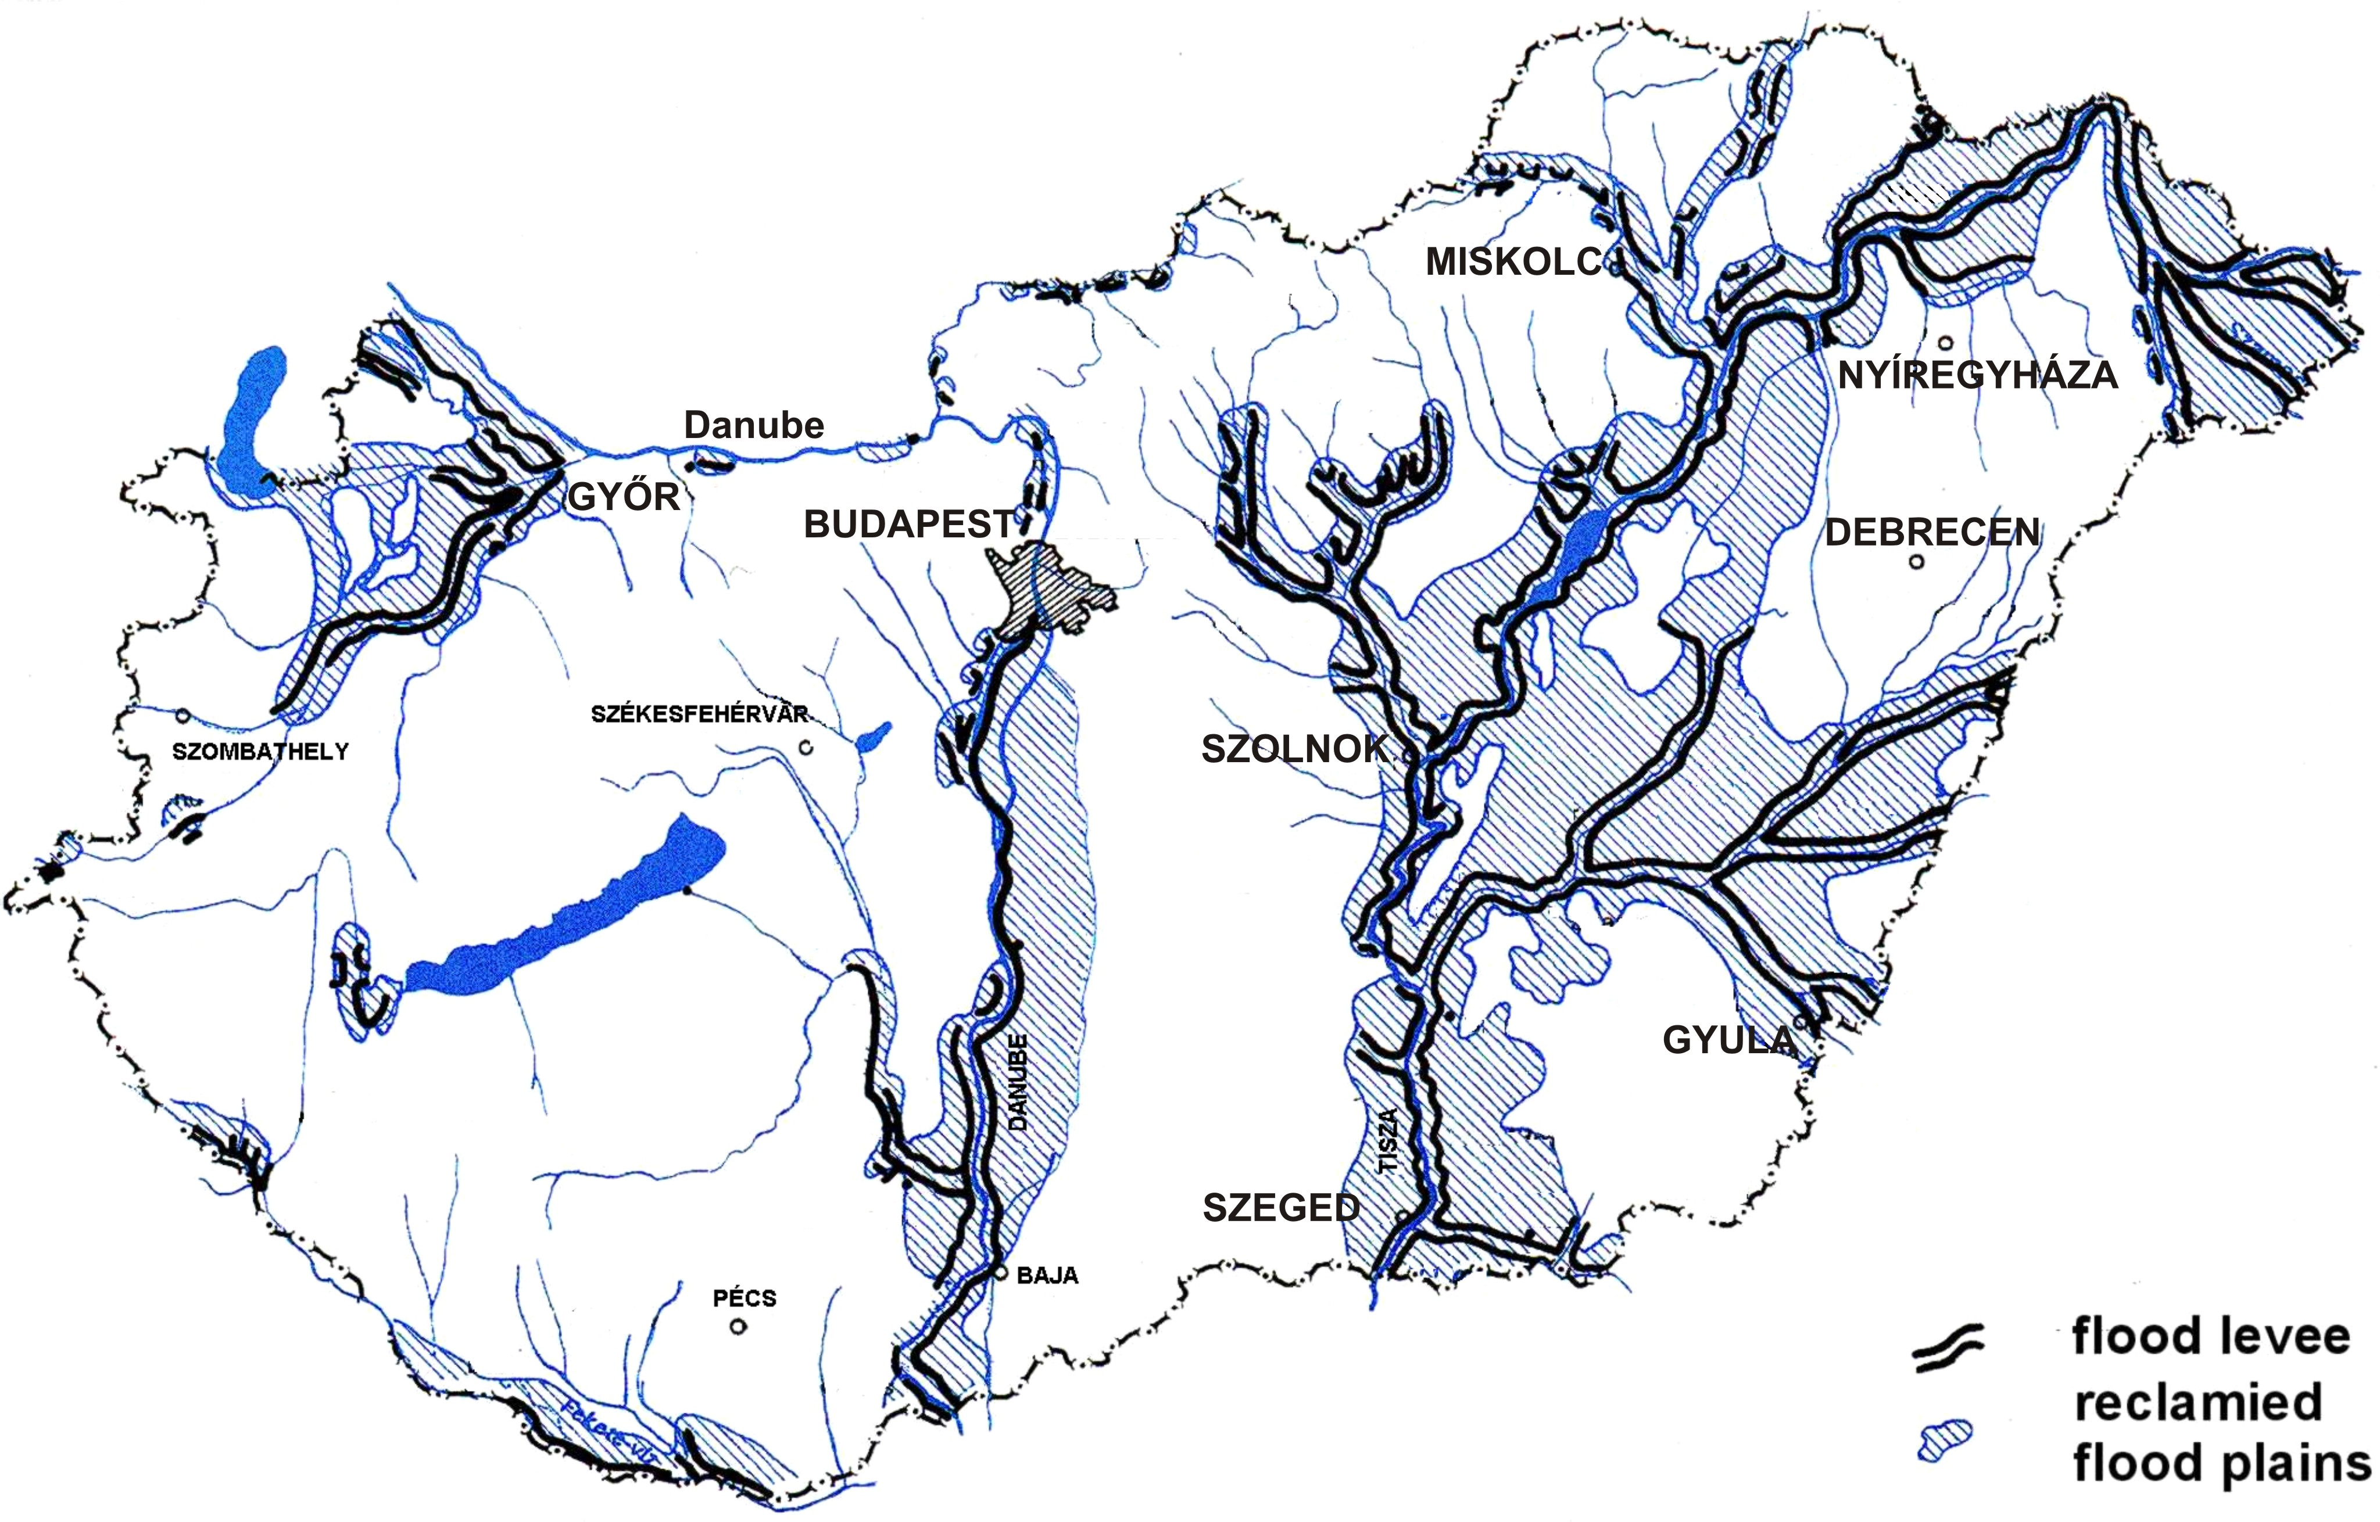

Rising flood peaks on the Tisza and her tributaries

