Project Title: | New Results in the Statistical Theory of Quantization, Modeling of Roundoff Errors in Computers and Their Reduction
Project Acronym: | Quantization and Roundoff
Project ID: | OTKA T-033053
Project URL: | http://www.mit.bme.hu/~kollar/topics/quant.html
Project duration: | 01.01.2000 - 31.12.2003
Funding from OTKA: | 7.716.000.- HUF
Project leader: | István Kollár
Organization: | Budapest University of Technology and Economics  Department of Measurement and Information Systems
Address: | H-1117 Budapest, Magyar tudósok krt. 2.
Phone: | + 36 1 463 1774
Fax: | + 36 1 463 4112
Email: | kollar@mit.bme.hu
URL: | http://www.mit.bme.hu/~kollar/

New Results in the Statistical Theory of Quantization, Modeling of Roundoff Errors in Computers and Their Reduction

OTKA T-033053

Roundoff (or, gin more general terms: quantization) occurs in every digital equipment. Quantities are represented by finite bit number words, so the true values need to be quantized. The statistical theory of quantization is based on the additive white noise model of the quantization error.
The conditions of good approximation have been recently analyzed in a doctoral thesis [1], and a book written in USA-Hungarian cooperation [2]. In these, the existing theory has been extended by new models, describing floating point number representation. These results opened new fields for research:
- further analysis of roundoff, associated with floating point number representation
- special dither signals (auxiliary signals which help to decrease the bias of quantization)
- generation of deterministic dither signals, advantages and disadvantages
- investigation of test procedures of A/D converters on the basis of the statistical theory of quantization, development of novel error limits
- characterization of the roundoff in IEEE double precision computers
- development of new and effective simulation procedures
These questions are becoming more and more important. Nowadays IEEE double precision number representation is implemented in almost all computers. Computer users are convinced that this precision solves all roundoff problems. However, we just begin to recognize the roundoff problems, which arise also in the use of the PC’s. Therefore, it is very important to have methods, which help to notice such problems, and to overcome them. This research is starting worldwide.
The results expected from this research:
- improved understanding of the phenomena helps to avoid false scientific predictions and implications. These will be published in the form of a book [2].
- analysis methods and suggestions for improvement will be elaborated for floating point computers. The aim is to decrease the errors by using the existing hardware.
The research is partly conducted in USA-Hungarian cooperation. We have also joined to the work of the EUPAS (European Project for ADC-based devices Standardisation) initiative.

[1] Kollár I., “Quantization Noise”. Doctoral Thesis at the Hungarian Academy of Sciences, Budapest, 1996. 416 p.
[2] B. Widrow and I. Kollár, “Quantization Noise”. Englewood Cliffs, Prentice-Hall. In preparation.

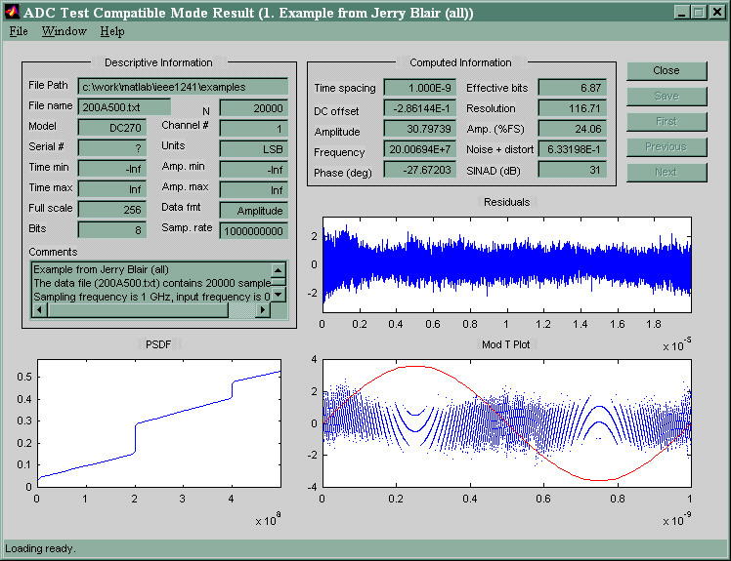
Display of the ADC testing program, developed in the frame of this research

