Project Title: | Acoustic Applications of Digital Signal Processing
Project Acronym: | -
Project ID: | OTKA F-035060
Project URL: | http://www.mit.bme.hu/eng/
Project duration: | 01.01.2001-31.12.2003
Funding from OTKA: | 2.328.000.- HUF
Project leader: | László Sujbert
Organization: | Budapest University of Technology and Economics  Department of Measurement and Information Systems
Address: | H-1117 Budapest, Magyar tudósok krt. 2.
Phone: | + 36 1 463 2679
Fax: | + 36 1 463 4112
Email: | sujbert@mit.bme.hu
URL: | http://www.mit.bme.hu/

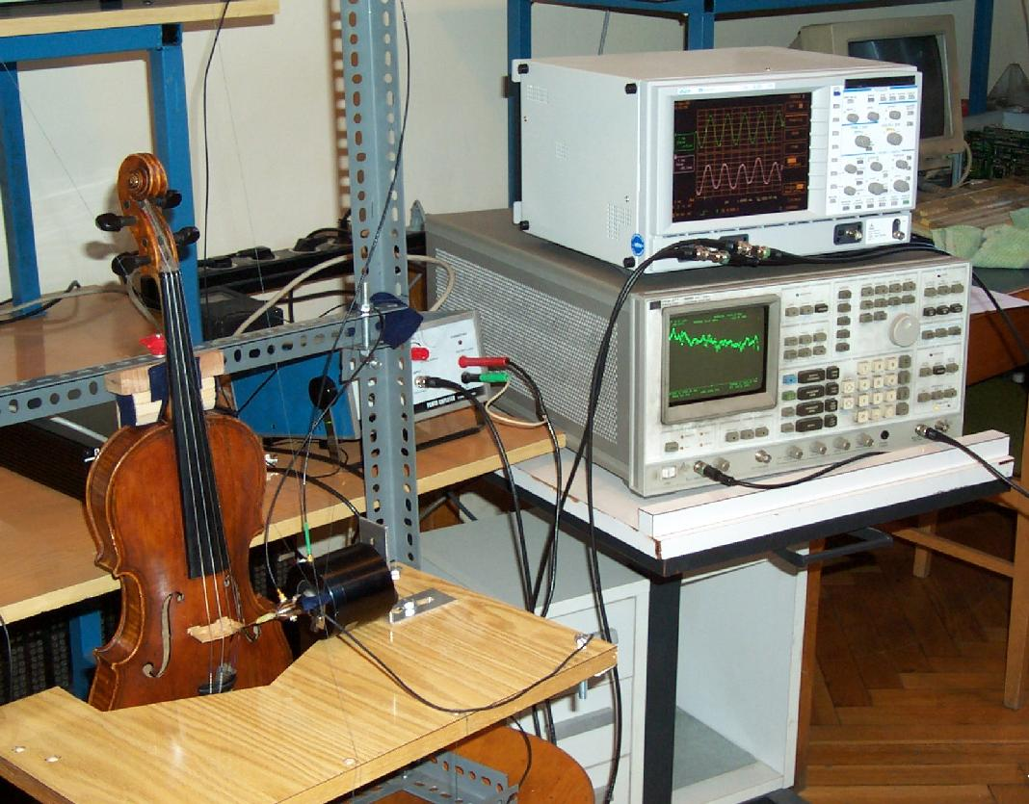
Acoustic Applications of Digital Signal Processing

OTKA F-035060

The aim of the project is to develop new algorithms and methods in the field of active noise control and digital musical sound synthesis. Active noise control and digital musical sound synthesis, especially physical modeling of the musical instruments is in the focus of scientific research.

Active noise control
The origin of the research is the noise control algorithm developed at the Department of Measurement and Information Systems, Budapest University of Technology and Economics. This algorithm can be used for active noise control where the noise to be suppressed is periodic. The algorithm shows better performance than the traditional methods. Based on the previous results, the research objectives are the following:

- A direct aim is to develop algorithm for suppression of stochastic disturbances, which algorithm is better than the usual methods concerning mainly its convergence speed and computational demand.
- A possible condition for robustness of noise control systems is the on-line adaptation of the model of the secondary path. Up to now there is no generally accepted method to solve this problem. Our research aims this problem, as well.
- Digital modeling of acoustic systems is also an aim of the project.

Digital musical sound synthesis
The topic is new at our department, but it has a very close relation to the other research projects in the field of measurement and signal processing. One of the researchers of the project works on his PhD thesis about digital sysnthesis of piano sound. The research objectives are the following:

- A direct aim is to describe the relation between the well-known digital waveguide model and the signal model (resonator) based approach.
- The digital waveguide model contains a filter, the specification of which is complex, i.e. both the amplitude and the phase requirements should be satisfied. The aim is to develop effective filter design methods.
- The excitation of the musical instrument requires a nonlinear model. Since each instrument requires its own excitation model, new results can be shown in this field, as well.
- Digital modeling of the mechanical system of the instrument should accomplish the synthesis.

The project is strongly connected to the other scientific research projects of the department, first of all in the field of adaptive signal processing, frequency domain identification and inverse filtering. The basis for experimental research is the signal processing laboratory of the department.

