Organisation and Address:
Agruniver Environmental Service and Management Ltd, H-2100 Gödöllő, Ganz-Ábrahám st. 2, POBox. 56, www.agruniver.hu

NAME and first name of the contact person by subjects of research:
MORVAI Balázs

Position: Deputy managing director

E-mail: bmorvai@mail.digitel2002.hu

Phone number: +36-28-417 463

Fax: +36-28-417 463

ABSTRACT of your research subject in MAXIMUM 10 lines (<500 characters):

Environmental site investigation & remediation

Under the 5th Framework Programme of the EC a decision tool software system and database are developed in for more proper investigation and revitalisation of contaminated sites (NORISC, 2001-2003). The company keeps track of European networks on pollution management, it is involved in a concerted action on brownfield redevelopment (CABERNET, 2002-2006). In the Biotechnology Programme of the Education Ministry of Hungary, microbiological treatment of hydrocarbon polluted soils is worked out (2001-2003).

Please indicate the thematic area you are interested in :
□ Genomics and biotechnology for health;
X Information technologies;
□ Nanotechnologies, new production processes;
X Food safety and health risks;
X Sustainable development (including chemical and environmental risks);
□ Citizens and governance in the European knowledge-based society

□ I need translation (please give the languages):

Please find more information on the next pages...
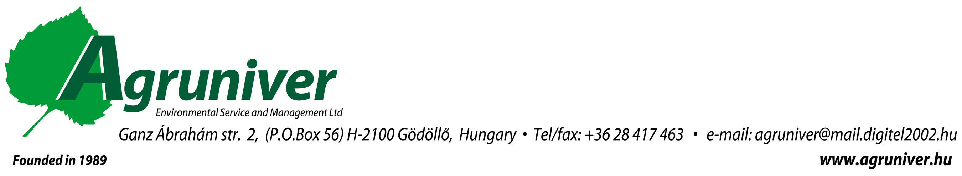

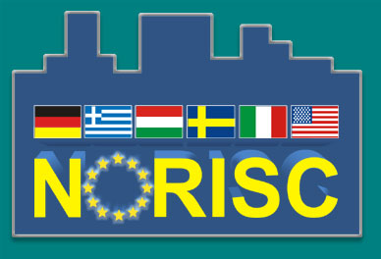
EC funded technology development: NORISC
www.norisc.com
Integrated decision support software (DSS) system for contaminated site redevelopment: under the 5FP in a RTD action (2000-2003) a DSS system, NORISC is developed that provides a cheaper and faster complex investigation scheme for polluted sites focusing on on-site techniques. The national contaminated site characterisation (preliminary evaluation, investigation, risk assessment) legislation and practice of different EU and associated member contries are integrated into the decision tool software system, focusing on cheap, fast and reliable new on-site investigation techniques (geophysics, analytic, hydrogeological tests, etc.). Revitalisation strategy is included into the related guideline system for abandoned industrial sites concerning environmental and socio-economic conditions of the site. In addition to single case manaegement, urban contaminated site registers and information systems are developed for appropriate city planning and urban environmental actions.
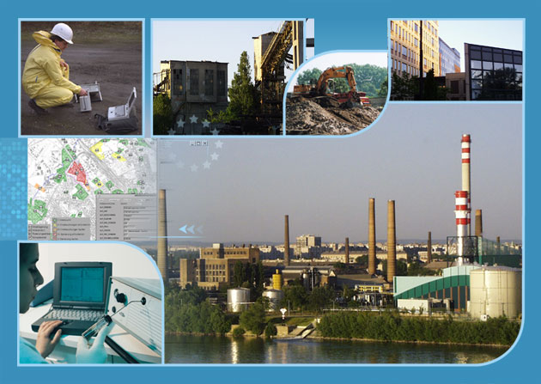
The NORISC project will provide a standard guide-line in the form of a decision support software system for efficient risk assessment of contamina-tion profiles in urban areas. This will be a valuable tool for city planners, decision-makers, landowners, investors and stakeholders. The guide-line will be used to improve site characterisation and risk assessment, as an approach for revitalisation of urban areas, to optimise land use, to minimise time and cost for investigation, redevelopment and remediation.

“Concerted Action on Brownfield and Economic Regeneration NETwork” CABERNET 2002-2005
We takes part in Concerted Action on Brownfield and Economic Regeneration NETwork that would provide a framework to enhance the incorporation of sustainable development into land use planning decisions, by focussing on the specific need to reuse the brownfield resource. This network of expertise would provide a basis for community wide interaction, and lead to the development of robust, relevant and pragmatic research complementing the concerted action.
National technology development project for stimulated biodegradation of contaminants, 2001-2003
Our main goal is to develop a stimulated biodegradation technology for elimination of hydrocarbon pollution.
Non-pathogenic microbes with wide range of hydrocarbon compounds decompositing activity are isolated and selected from soils of contaminated sites.

Duration of decomposition: 1-6 months for light hydrocarbons (petrol, kerosene, gasoline, heating oil, extractants), while 3-12 months for heavy hydrocarbons (mineral oil, lubricants). We have PAH decomposition microbes, heavy metal fixing microbes.

Expression of Interest for 6th Framework Programme
A consequent project under the 6th Framework Programme of the EC should be an integrated project for expansion of the currently provided decision tool software system in order to cover the whole process of contaminated site management. The recent version of NORISC focuses on time and cost effective site investigation based basically on on-site and in situ methods. An Expression of Interest on this topic has been submitted to the EC in June, 2002.

