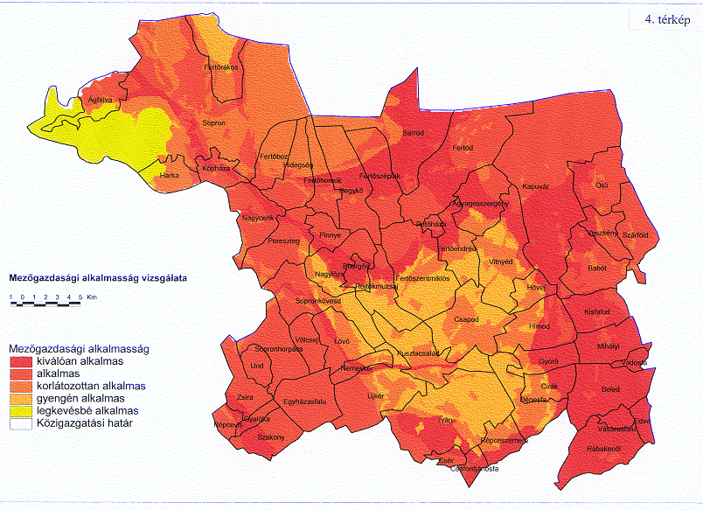

Map 4 Agricultural suitability — LUT₃ (red: suitable, yellow less suitable)

