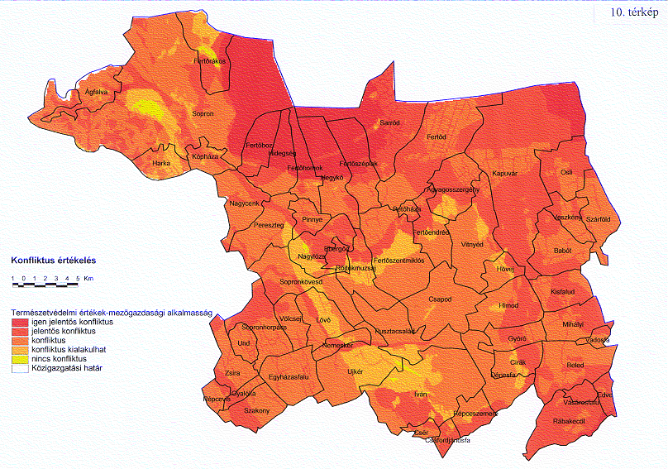

Map 8 Conflict analysis between nature values and agriculture (red: significant conflict, yellow no conflict)

