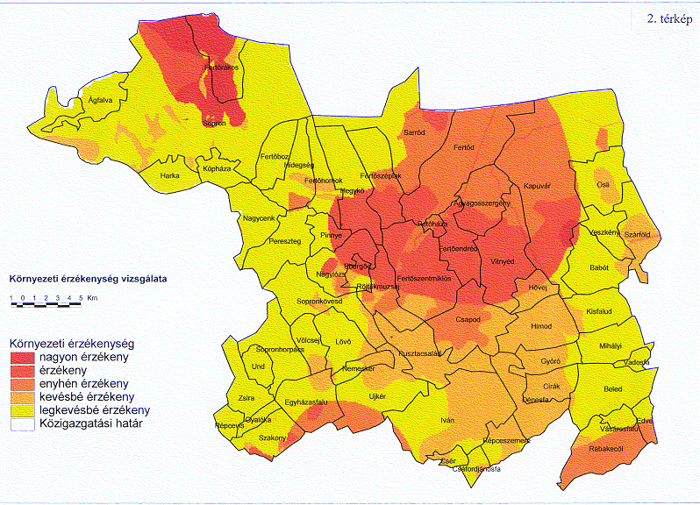

Map 2 Environmental sensitivity — LUT₁ (red: sensitive, yellow: not sensitive)

