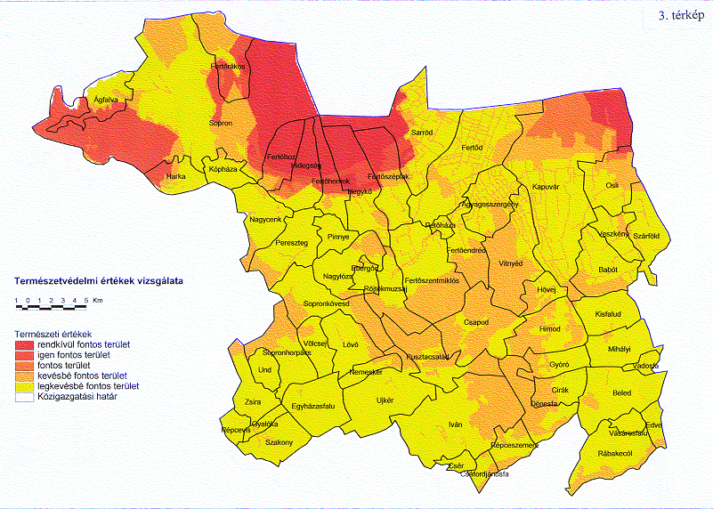

Map 3 Natural and landscape values — LUT₂ (red: significant, yellow less important)

